International Student Orientation
Manual



Prepared
April 25, 2016

Table of Contents
- Pre-Arrival Communication
  - What is it?
  - University-Wide Pre-arrival Communication Plan
  - Incoming Groups
  - Program Officer Contact
  - Parent & Family Letter
  - Social Media Strategy
  - Appendix
    - Templates for Incoming Groups
    - Templates for Orientation Leader Campaigns (2016)
- Managing Lists
  - Overview
  - Importing into Mailchimp
  - Calculating the Headcount
  - Example: Fall 2015 Orientation Headcount
- Orientation Mentors
  - Overview
  - List of 2016 Peer Mentors
  - Training Manual
  - Summer Communication Timeline (2015)
- Orientation Logistics
  - Past Orientation Sessions (Fall 2015)
  - Orientation Make Up Session (Fall 2016)
  - International Student Orientation Programs (Fall 2016)
  - Welcome Week Schedule
  - Fall 2016 Orientation Schedule
  - Fall 2016 Learning Outcomes
  - Session Learning Outcomes (Fall 2015)
  - Example Evaluations (Fall 2015)
  - List and locations of session Powerpoints
  - List of All Food Orders (2016)
  - Example of Food Orders (Fall 2015)
  - Supplies: List of Supply Categories
  - Orientation FAQ for the Front Desk
- Website
  - Orientation Landing Page
  - Freshmen Page
  - Parent Page
  - Transfer Page
  - Graduate Student PageF
  - Other Pages

- Budget
- Global Café
  - Food and supply list
  - Calendar of Global Cafes’ / Themes
  - Marketing
Pre-Arrival Communication
What is it?
Pre-arrival communication is an e-mail based campaign of information dissemination to students before they arrive. Its primary objectives are (1) to introduce ISSS and establish correspondence with students for any questions they might have (2) alert students to any pertinent paperwork, payments, or deadlines before they arrive on campus. (3) Describe the time, location and structure of International Student Orientation (4) Connect incoming students with an Orientation Mentor for any student-to-student questions.
University Wide Communication Timeline
The university-wide communication timeline has not yet been established for 2016, so the example below is from Fall 2015. Messages in bold and blue are from ISSS.
Date | Content of Message | Recipient
03/31/15 | First Year Guide for Fall Email | All Students
04/01/15 | Financial Aid Verification Letters | US Freshmen
04/15/15 | First Steps to Success Email to Early Decision Families | All Students
04/30/15 | Enrollment Deposit Received Email | All Students
04/30/15 | Eagle Summit Brochure Mailing | US Freshmen
04/30/15 | Pre-Registration Email to Regular Decision Students | All Students
05/04/15 | ED: AU Students First Steps to Success (e-mail) | Parents & Family email
05/04/15 | RD: AU Students First Steps to Success (e-mail) | Parents & Family email
05/04/15 | Regular decision letters | Student (hard copy letter)
05/04/15 | ED: Get Ready to Register (e-mail) | All Students
05/04/15 | RD: Get Ready to Register (e-mail) | All Students
05/06/15 | First Steps to Success Email to Regular Decision Families | US Freshmen
05/08/15 | FR1: Welcome | Welcome to AU from ISSS! | Introductions, myAU account creation, orientation dates, fast facts, Blackboard portal, parent orientation, next steps | FR
05/08/15 | USGN1: Welcome | Welcome to AU from ISSS! | Introductions, GN video, orientation dates, myAU account creation, Blackboard portal, next steps | USGN
05/12/15 | Complete Pre-Registration Planner Email to Early Decision | US Freshmen
05/15/15 | FR2: Peer Mentorship Introdctuon | Introducing the International Peer Mentorship Program | Program description and link to profiles | FR
05/15/15 | FR1: Welcome (resend to unopened) | Welcome to AU from ISSS! | Introductions, myAU account creation, orientation dates, fast facts, Blackboard portal, parent orientation, next steps | FR
05/15/15 | USGN2: Peer Mentorship Introduction | Introducing the International Peer Mentorship Program | Program description and link to profiles | USGN
05/15/15 | USGN1: Welcome (resend to unopened) | Welcome to AU from ISSS! | Introductions, GN video, orientation dates, myAU account creation, Blackboard portal, next steps | USGN
05/16/15 | Early Decision Planner | US Freshmen
05/18/15 | ED: It’s Time to Complete your Student Planner (email) | Student AU e-mail only
05/18/15 | Fall Housing Application - STEP 2: Roommate Matching invitation | US Freshmen
05/19/15 | Complete Pre-Registration Planner Email to Regular Decision | US Freshmen
05/21/15 | GR1: Welcome | Welcome to American University! | Introductions, myAU account creation, orientation dates, off-campus housing resources, Blackboard portal, next steps | GR
05/22/15 | F-1 & J-1 SEVIS Processing Warning | Alert! SEVIS Processing delays between June 25 and June 30 | Processing delay dates, important date info, Blackboard portal | FR
05/22/15 | F-1 & J-1 SEVIS Processing Warning | Alert! SEVIS Processing delays between June 25 and June 30 | Processing delay dates, important date info, Blackboard portal | GR
05/23/15 | Regular Decision Planner | US Freshmen
05/26/15 | Last Push Orientation Phone Calls | US Freshmen
05/31/15 | Early Decision Registration | US Freshmen
06/01/15 | Health Insurance Waiver Email | US Freshmen
06/01/15 | Welcome Week Brochure Mailing | US Freshmen
06/01/15 | Combined Master Promissory Note and Entrance Counseling Reminder / Entrance Counseling / Master Promisory Note Email | US Freshmen
06/01/15 | ED: Registration Deadline | US Freshmen
06/03/15 | TR1: Welcome | Welcome to AU! | Introductions, myAU account creation, orientation dates, fast facts, Blackboard portal, parent orientation, next steps | TR
06/05/15 | FR3: Orientation Registration and Family & Parent Letter | Register Now for International Orientation | Parent letter, orientation registration reminder, parent orientation, Blackboard portal, next steps | FR
06/05/15 | GR2: Peer Mentorship Introduction | Introducing the International Peer Mentorship Program | Program description, 3 grad mentor profiles w/contract info, myAU account creation, Blackboard portal | GR
06/05/15 | USGN3: Orientation Registration and Family & Parent Letter | Orientation Registration and Family & Parent Letter | Parent letter, orientation registration reminder, parent orientation, Blackboard portal, next steps | USGN
06/05/15 | Housing Vendor Information Mailing | US Freshmen
06/06/15 | Regular Decision Registration | US Freshmen
06/08/15 | RD: Registration Deadline | US Freshmen
06/09/15 | GR1: Welcome (segment copy to added Grads) | Welcome to American University! | Introductions, myAU account creation, orientation dates, off-campus housing resources, Blackboard portal, next steps | GR
06/16/15 | FR4: Pre-Arrival Immigration Checklist | Lets Go Over Your Pre-Arrival Checklist | Receiving the I-20, paying the SEVIS fee, request a visa appt, visa interview, entering the US, pre-arrival guide, link to register for orientation, next steps list | FR
06/16/15 | GR3: Orientation Registration | Register Now for International Orientation | Link to register for orientation, info on living in DC, next steps list | GR
06/16/15 | GR1: Welcome (copy to J-1 scholars) | Welcome to American University! | Introductions, myAU account creation, orientation dates, off-campus housing resources, Blackboard portal, next steps | GR
06/16/15 | GR2: Peer Mentorship Introduction (copy to J-1 scholars) | Introducing the International Peer Mentorship Program | Program description, 3 grad mentor profiles w/contract info, myAU account creation, Blackboard portal | GR
06/16/15 | GR3: Orientation Registration (copy to J-1 scholars) | Register Now for International Orientation | Link to register for orientation, info on living in DC, next steps list | GR
06/16/15 | TR1: Welcome (copy to Transfers added 6/16) | Welcome to AU! | Introductions, myAU account creation, orientation dates, fast facts, Blackboard portal, parent orientation, next steps | TR
06/16/15 | Complete Master Promissory Note and Entrance Counseling for Perkings Loan Email and Letter | US Freshmen
06/19/15 | TR2: Orientation Registration and Family & Parent Letter | Register Now for International Orientation | Family letter, orientation registration, parent orientation, Blackboard portal | TR
06/20/15 | Eaglesummit Begins | US Freshmen
06/23/15 | FR1: Welcome & Orientation Registration (copy to Other Visas 06.23) | CORRECTION: Welcome to AU & Fixed Orientation Registration Link | | FR
06/23/15 | GR1: Welcome (copy to Other Visas 06.23) | Welcome to American University! | Introductions, myAU account creation, orientation dates, off-campus housing resources, Blackboard portal, next steps | GR
06/23/15 | GR2: Peer Mentorship Introduction (copy to Other Visas 06.23) | Introducing the International Peer Mentorship Program | Program description, 3 grad mentor profiles w/contract info, myAU account creation, Blackboard portal | GR
06/23/15 | GR3: Orientation Registration (copy to Other Visas 06.23) | Register Now for International Orientation | Link to register for orientation, info on living in DC, next steps list | GR
06/23/15 | GR4: Pre-Arrival Immigration Checklist | Lets Go Over Your Pre-Arrival Checklist | Receiving the I-20, paying the SEVIS fee, request a visa appt, visa interview, entering the US, pre-arrival guide, link to register for orientation, next steps list | GR
06/23/15 | TR3: Pre-Arrival Immigration Checklist | Lets Go Over Your Pre-Arrival Checklist | Submit CFIS form, complete the Transfer form, receiving your I-20, obtrain a new visa, pre-arrival guide, register for orientation, Blackboard portal | TR
06/23/15 | USGN4: Global Nomads 4 | Global Nomad & TCK Resources | Denizen, Obama TIME article, Where's Home video, orientation registration, Blackboard portal | USGN
06/24/15 | FR5: Finance & Tuition Payment Options | Let's Go Over your Finance & Tuition Payment Options | Payment deadline, plan overview, Eagle Finance video tutorial, mail instructions, banking options | FR
06/24/15 | FR6: Welcome Reception Invitation | You Are Invited! Fall 2015 International Student Welcome Reception! | Invitation with button to RSVP | FR
06/24/15 | GR5: Welcome Reception Invitation | You Are Invited! Fall 2015 International Student Welcome Reception! | Invitation with button to RSVP | GR
06/24/15 | TR4: Welcome Reception Invitation | You Are Invited! Fall 2015 International Student Welcome Reception! | Invitation with button to RSVP | TR
06/24/15 | USGN5: Welcome Reception Invitation | You Are Invited! Fall 2015 International Student & US Global Nomad Welcome Reception! | Invitation with button to RSVP | USGN
06/30/15 | Tuition Refund Letter | US Freshmen
06/30/15 | Fall Housing Application - STEP 3: Room Selection Invitation | US Freshmen
07/01/15 | GR6: Finance & Tuition Payment Options | Let's Go Over your Finance & Tuition Payment Options | Payment deadline, plan overview, Eagle Finance video tutorial, mail instructions, banking options | GR
07/01/15 | TR5: Finance & Tuition Payment Options | Let's Go Over your Finance & Tuition Payment Options | Payment deadline, plan overview, Eagle Finance video tutorial, mail instructions, banking options | TR
07/01/15 | USGN6: Finance & Tuition Payment Options | Let's Go Over your Finance & Tuition Payment Options | Payment deadline, plan overview, Eagle Finance video tutorial, mail instructions, banking options | USGN
07/01/15 | Grant Parents Access to Portal Information Email | US Freshmen
07/08/15 | GR1: Welcome (copy to 7/8 added) | Welcome to American University from ISSS! | | GR
07/14/15 | August Orientation / Fall Housing Information | US Freshmen
07/15/15 | Alcohol and Sexual Assault Online Education Emails and Postcards | US Freshmen
07/16/15 | Complete MPN and Entrance for Perkins Loan / Payment Plan Due / Balance Due Letters and Emails | US Freshmen
07/31/15 | Confirming Eagle Summit Registration Email | US Freshmen
08/01/15 | Building Welcome Letter | US Freshmen
08/03/15 | Connecting to AU's Network and Getting Help Email | US Freshmen
08/04/15 | All-American Weekend Brochure | US Freshmen
08/15/15 | Enrollment/SAP Reminders Emails | US Freshmen
08/16/15 | Complete Online MPN and Entrance for Perkins Loan Letters and Emails | US Freshmen
08/16/15 | Payment Plan Payment Due Email | US Freshmen
08/16/15 | Term Bills Sent for Balance Due Mailing | US Freshmen
08/20/15 | Welcome Week and Off-Campus Parties Email | US Freshmen
08/21/15 | Fall Housing Application - STEP 1: Online Application Invitation | US Freshmen
08/31/15 | Welcome Week Confirmation Email | US Freshmen
09/16/15 | Complete Online MPN and Entrance for Perkins Loan Letters and Emails | US Freshmen

Incoming Groups
Messages are tailored to the specific needs of the incoming groups. ISSS only communicates with incoming degree-seeking international students. Students not attending ISO receive all pre-arrival communication from their relevant program officer. Students attending ISO, but who are part of a special cohort, (e.g. WMP, IAP, Ritsumeikan) also receive all communication from the relevant program officer.
All Incoming International Students to AU | Groups Attending ISO
- Washington College of Law | - Degree-seeking FR, TR, GR students
- Abroad @ AU | - Global Nomad Freshmen
- Washington Mentorship Program | - Washington Mentorship Program
- Washington Semester Program | - Graduate Gateway Program
- Graduate Gateway Program | - International Accelerator Program (4pm session only)
- International Accelerator Program | - Ritsumeikan Dual Degree?
- Ritsumeikan Dual Degree?
- SIS Semester Exchange Students
- Graduate (SPA, SIS, CAS, SOC) Semester Exchange
Students Receiving ISSS Pre-arrival Communication
- Degree-seeking FR, TR, GR students on an F-1 or J-1 visa sponsored by AU
- Graduate Fulbrights (other sponsor)
- Degree-seeking US Global Nomads and Other Visa holders
- Orientation Leaders / Peer Mentors

List of Program Officers

Student NOT attending ISO, not receiving messages from ISSS | Contact
- Washington College of Law | Alberto Lopez | allopez@wcl.american.edu  (202) 274-4114
- Abroad @ AU | Sarah Harlow | harlow@american.edu  202-885-1329
- Washington Semester Program | Donna Chapman | dchapman@amerian.edu  (202) 895-4912
Students Attending ISO, not receiving messages from ISSS
- Washington Mentorship Program | Elizabeth Slupski | slupski@american.edu  (202) 895-4936
- Graduate Professional Studies | Lana Knox | knox@american.edu  (202) 895-4859
- International Accelerator Program
- Ritsumeikan Dual Degree | Amy Marrion | amarrion@american.edu  (202) 885-1606
- SIS Semester Exchange Students | Amy Marrion | amarrion@american.edu  (202) 885-1606
- Graduate (SPA, SIS, SOC) Semester Exchange | SIS: Jia Jiang  SOC: Jean McGee  SPA: Melissa Blanco | jiang@american.edu  (202) 885-1689  jmcgee@american.edu  (202) 885-2078  mblanco@american.edu  (202) 885-6407

Social Media Strategy (Fall 2017)
Facebook
- ISSS Facebook Page - Mirrors announcements in the pre-arrival FR campaigns

Appendix
Templates for Incoming Groups
- Freshmen
- Transfer
- Graduate
- USGN (Freshmen)
- Other Visa (Freshmen)
- Graduate (J-1 Fulbright)
Templates for Orientation Leader Campaign
- This Week in Peer Mentorship

Managing Lists
Overview
List management is one of the constant tasks of orientation. There are several lists to maintain. (1) The list of students in the pre-arrival campaign through Mailchimp. (2) The list of students actually attending orientation (which may include students whose primary contact is another Program Officer). (3) A general list of all incoming students on a student visa (regardless of whether they are coming to our orientation or in our pre-arrival campaigns). Orientation-driven examples for the need for this third type are typically ad hoc, such as to announce any SEVIS-wide blackout dates, or new health insurance requirements for J-1 visas. Pulling this third list is the easiest can be done directly in ISSIS on an as-needed basis.

Calculating a Headcount
- In the ISSIS Home Screen, click on “Reports Menu” under “Other Menus”
- Under “Admitted Student Statistics,” be sure the term is set to the upcoming orientation, e.g. 2016F, and click on “Send me the Report”
  - If it is not set to next orientation, change the term to the appropriate semester, and click “Update” in the upper right hand corner.
  - The data is pulled overnight, so if you’ve had to do this, you’ll need to wait until tomorrow to pull the list.
- The Admitlist will be emailed to you.
- Save the Admitlist in your Orientation Folder on the K drive. I like to use a folder called “List of Students”
- From excel, open file and navigate to the Admitlist that you’ve just saved. Make sure that you are viewing “All Files” under the File Type dropdown menu so that you can see it.
- When you open the file, a Text Import Wizard will appear
  - Choose “Delimited” click next
  - Select both “Tab” and “Semicolon” as text delimiters. Click next
  - Click FINISH
  - This will create a sheet called “A26.ISS.ADMIT”
- CTRL-A to Select All. Copy. In a new tab (down below), paste your copied data. (This preserves the raw data in case you make any mistakes). Name the new tab. “Headcount”
- Clean Up the Sheet
  - Delete Row 2
  - Delete Columns O “PIIRF” onwards (to the right)
  - In the Mailchimp sheet, select all and Format as Table in the Home Menu above.
  - In the “School” column: filter out and delete SABD, Unknown, WCL,
  - Under “APPL Status” filter out and delete “Withdrawn after Decision” and “Deposit Paid/Deferred Admit”
  - Under the “Admit Status” column m filter out and delete any rows with the term “Visiting”
- Append Global Nomads to this list
  - Go to the “Fall 2016 Tracking Chart” in Google Drive (Ask Evelyn’s Team for access)
  - Under FILE Download As, Select “Microsoft Excel”
  - Save the file in your “List of Students Folder” as “YYYY.MM.DD--Fall 2016 Tracking Chart.xls”
  - Open the file. Go to the FR GN tab. Using the “Status” Column filter out any value that isn’t “MS”
  - Highlight all ID numbers. copy.
  - Go to where your data ends on your “Headcount” sheet in your Admitlist excel file. Paste.
  - Now you’ll need the names, but in the “Fall 2016 Tracking Chart” file these are in two separate columns. You can easily concatenate these values and separate with a column, but it might be even easier to just look up names and e-mail addresses in ISSIS.
    - Open ISSIS, go to Email Menu
    - Select “List of Student ID numbers” and Paste the USGN ID numbers into that field.
    - On the next screen, “View Recipients” This should give you a list of names and ID numbers. CTRL-A. copy. In a new tab on your Admitlist file, paste values.
    - Insert a column after the “Name” column
    - Do Text-to-Columns above and choose hyphen “-“ as a delimiter. Finish. Be careful not to overwrite the email address data. This should give you one column of ID numbers, one column of names, and two email columns.
    - Go back to your “Headcount” sheet. In the first blank cell of the Global nomad ID numbers (that you just pasted from the Tracking Chart), type this:
    - =vlookup(lookup_value, table_array, col_index_num, [range_lookup])
      - Where Lookup-Value is the first AUID number in question
      - Table_Array is the table of GN names and emails you just pulled out of ISSIS
      - Col_index number is the column number the data is found in. For names, this is likely “2”.
      - Leave Rangelookup blank. Close parentheses.
      - This will give you the name of the first Global Nomad. Drag the formula down to the last unnamed AUID number.
      - Highlight the data you just created, and paste values in place.
      - Repeat this formula to get the “AU Email Address” and “Other Email address”
      - Don’t forget to paste values in place of the formulas once they’ve done their work.
- Best practice note: The ISSIS values in the AdmitStatus column were created years before a number of different programs have emerged. Though it takes a bit of work, I strongly recommend spending some time looking at the list and replacing any uninformative values in the AdmitStatus column.
  - For example, we know that anyone with the email address “admissions@auaccelerator.com” is an IAP student, but the Admitlist column calls them “Nondegree Traditional Undergrd” It might be helpful to replace those values here.
  - Reference the section of this document called “Incoming Groups” to try to parse the student into the appropriate programs, since tags like WMP, Wash Sem are not in the AdmitList.
  - If necessary, contact the Program Officers and have them send you the list. You can then cross-reference your Headcount list with their list (using =countif) to name the AdmitList values appropriately.
- Do a basic Headcount
  - Highlight all of your columns of data in the “Headcount” tab
  - Under the INSERT menu above, click Pivot Table, New Worksheet
  - 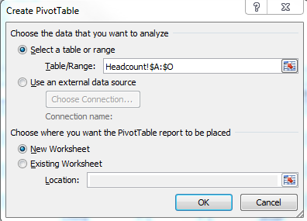
  - Once created, your Pivot Table will look like this:
  - 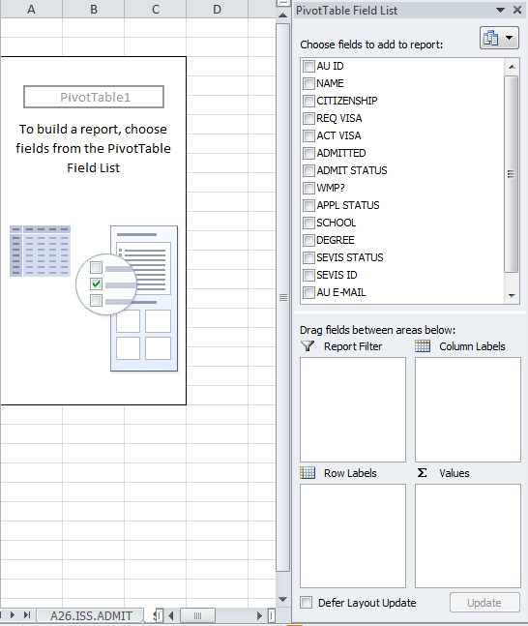
  - Drag “Admit Status” from the “Choose fields to add to report” down to the Row Labels region
  - Drag “AUID” down to the Values region. This is your total. It may look like this:
  - 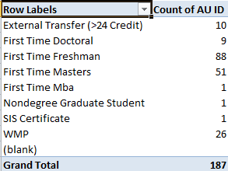
  - Some categories are mixed. For example, First Time Freshmen are comprised of both F-1 students and Global Nomads. To split this out, drag “REQ VISA” down to the “Column Labels” region.
  - Your Pivot Table will now look something like this:
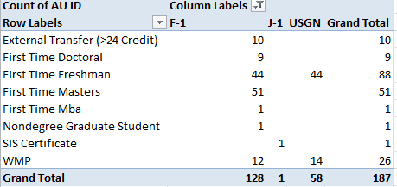
  - Note, this does not include Parents & Family. For that info, please see Garrett (below).

Example: Fall 2015 Orientation Headcount

Please note that while Registrants are critical for planning for the number of parents and family, we usually make preparations based on the invited list, since students who fail to register for orientation are not turned away on the day itself.

Invited List |  |  | Registrants
Certificate | 9 |  | Simplicity 08/15/2015
Doctoral | 20
Freshman | 174
International Gateway Program | 45
Masters | 128 |  | Family | 124 |  | Family
Nondegree Graduate | 5 |  | Freshmen | 151 |  | Freshmen | 284
Transfer | 52 |  | Transfer | 22 |  | Transfer | 52
Washington Mentorship Program | 56 |  | Graduate | 104 |  | Graduate | 153
 | 489 |  |  | 401 |  |  | 489
 |  |  | OA's | 42
 |  |  | Student Workers | 5
 |  |  | ISSS Staff | 6
 |  |  | Presenters | 6
 |  |  |  | 59
 |  |  |  | 460

Ask Garrett Schlicte (http://www.american.edu/profiles/staff/garretts.cfm) for a list of registrants from simplicity.
*Simplicity will be replaced after this orientation, so I didn’t include a tutorial on pulling registrant from this moribund system. Garrett is usually happy to share.
But just in case:
simplicity login
american-nso.symplicity.com/manager
perla@american.edu
AUEagles14

Orientation Mentors
http://www.american.edu/ocl/isss/International-Orientation-Leader.cfm

Overview
International Orientation Leaders are American University students who assist the International Student and Scholar Services office in making International Orientation happen. Serve as a guide for new international students, give advice on being a student at AU to new international students, provide encouragement and support for students undergoing social, cultural and academic transition, and facilitate the implementation of orientation programs for new international students.
List of Fall 2017 Orientation Leaders
For Fall 2017, there are a total of 30 Orientation Leader. For complete information, including gender, citizenship, location this summer, etc. please see: Handouts
Last Name | First Name | AU ID | Phone Number | Email Address | School
Togrul | Nazli | 4142183 | 4048632015 | nt2183a@student.american.edu | SOC
Desmone | Joseph | 4221184 | 4122289774 | jd1184a@student.american.edu | SIS
Brenner | Scott | 4086735 | 2153546497 | sb6735a@student.american.edu | SPA
Schaefer | Kate | 4269053 | 4077653199 | ks9053a@student.american.edu | SIS
Tang | Krystal | 4052079 | 2028123602 | yt2079a@student.american.edu | KOGOD
Taylor | Kiara | 4477810 | 4045877437 | Kt7810a@student.american.edu | SIS
Rebolledo | Daniela | 4478323 | 2408480486 | Dr8323a@american.edu | CAS
Castro | Veronica | 4249121 | 5715286963 | Vc9121a@student.american.edu | SOC
Parrotta | Isabella | 3943354 | 4439007910 | ip3354a@student.american.edu | SIS
Diaz | Sophia | 4213762 | 9739978753 | sd3762a@student.american.edu | SIS
Ochoa | Diana | 4096127 | 3013856474 | do6127a@student.american.edu | SOC
Rock | Brittany | 2136773 | 3155279775 | berock@american.edu | CAS
Gabrielle | Chishinsky | 4110482 | 2015186669 | gc0482a@student.american.edu | SIS
Samak | Mithila | 3679435 | 202-746-4168 | ms9435a@student.american.edu | SOC
McPherson | Marisa | 4018880 | 5417600506 | mm8880a@student.american.edu | SPA
Prasad | Anusha | 4080682 | 9082553977 | ap0682a@student.american.edu | SIS
Vega | Angelica | 4347420 | 7326368113 | av7420a@student.american.edu | CAS
Thai | William | 4259386 | 808-688-6556 | wt9386a@student.american.edu | CAS
Kanybek Kyzy | Nargiza | 4141179 | 5074567892 | nk1179a@student.american.edu | SIS
Pierre-Paul | Christiana | 4138642 | 202-758-9532 | cp8642a@student.american.edu | SPA
O'Shea | Katie | 2638332 | 719-651-5014 | ko8332a@student.american.edu | CAS
Hernandez | Eli | 4347378 | 6094550302 | eh7378a@american.edu | CAS
Perry | Britton | 4347828 | 4058698887 | bp7828a@student.american.edu | SIS
Zeballos-Perez | Julliette | 4687181 | 5712797531 | Jz7181a@student.american.edu | KOGOD
Fishbein | Adam | 4208002 | 2675971600 | af8002b@student.american.edu | SPA
Vayser | Shayna | 4188318 | 9493091901 | sv8318a@student.american.edu | SIS
Le | Lam-Anh | 41005635 | 408.828.3653 | ll5635a@student.american.edu | SIS
Jamal | Nezar | 4134829 | N/A | nj4829a@student.american.edu | SIS
Turmakhanov | Abulkhair | 4327734 | N/A | at7734a@american.edu | N/A

Orientation Leader Training Manual
Fall 2017 Training: Learning Objectives | 2017 Training Scheduled: August 19, 2017
- Community Building / Ice Breaker
- Final Orientation Schedule Overview
- Review of Role Modelling and Expectations
- Assign Teams and Individual Tasks
- Distribute Floor Plan and Positions
- Immigration Check-in Training
- Immigration Documents Collection Training
- Orientation Check In Training
- Session Assistance / Community Showcase training
- Simulation: Orientation Practice

Fall 2017 Orientation Leader Training
Saturday, August 19 9:00am to 5:00pm MGC 331N

Time | Session
9:00am-9:30am  30 minutes | Welcome & Introductions: Ball Name Game Icebreaker  -Everyone shares their Name, Program, Year, Country, Fun fact  -Say the name of the person, then throw them the ball
9:30am-10:30am  1 hour | Overview of Orientation  -Schedule Overview  -Assign Roles
10:30-11:00am  30 minutes | Simulation  -Saturday run-through
11:00am-11:15am  15 minutes | Break  *Order Lunch
11:15am-12:15pm  1 hour | OL Session Training (Require Grad Students to do Campus Tour)  -Use four corners to divide OAs accordingly: Grads, Non-degree, PM, Transfer
12:15pm-1:00pm  45 minutes | Lunch
1:00pm-2:00pm  1 hour | Walk-Throughs  -Sunday Walkthrough
2:00pm-3:00pm  1 hour | OL Training in the Tavern  -OL Roles and Expectations Overview  -Concurrent Planning
3:00pm | Distribute T-shirts

Orientation Logistics
Past Orientation Sessions (Fall 2015)
Below are the articulated learning outcomes for three content based sessions of (1) Cross Culture (2) Academics (3) Immigration rights and responsibilities. Beyond these, the orientation schedule includes (4) Introduction to Campus Resources (5) Orientation Leader Session.
Orientation Make Up Sessions (Fall 2017)
The following make up dates have already been confirmed in 25Live and by the University Scheduling Team. Do not make Orientation Make Up sessions available to students until Monday, August 21. You can leave a clipboard at the front desk with an Orientation Make Up Sign Up sheet for each date, OR, you can create a google form with the options below and save the link to one of the student computers by the front desk.
- Wednesday, August 23, 09:00AM-10:00AM (MGC 323)
- Monday, August 28, 09:00AM-10:00AM (MGC 247)
- Monday, August 28, 3:00PM-4:00PM (MGC 247)
- Friday, September 1, 9:00AM-10:00AM (MGC 247)
- Friday, September 1, 3:00PM-4:00PM (MGC 247)
International Student Orientation Programs
- Freshmen
http://www.american.edu/ocl/isss/intl-orientation-freshmen.cfm
  - Sunday, August 20 (International Student Orientation; ISSS)
  - Monday, August 21 (Eagle Summit; OCL)
  - Tuesday, August 22 (Eagle Summit; OCL)
- Transfer
http://www.american.edu/ocl/isss/intl-orientation-transfer.cfm
  - Sunday, August 20 (International Student Orientation; ISSS)
  - Tuesday, August 22 (Transfer Transitions; OCL)
- Graduate
http://www.american.edu/ocl/isss/Graduate-Orientation.cfm
  - Sunday, August 20 (International Student Orientation; ISSS)
  - Variable: See their department or school/college’s orientation: http://www.american.edu/ocl/orientation/Graduate-Student-Orientation-Programs.cfm
- Abroad at AU (not managed by ISSS)
http://www.american.edu/ocl/isss/Abroad-at-AU-January-Orientation.cfm
- Washington Semester (not managed by ISSS)
http://www.american.edu/ocl/isss/WSEM-orientation.cfm
- Washington College of Law (not managed by ISSS)
https://www.wcl.american.edu/orientation/

Welcome Week Schedule
*INSERT IMAGE HERE*

Fall 2017 International Orientation Schedule
Sunday, August 20

8:00 | Passport Collection (Ward 101: JC; Ward 102: MH & SP; Ward 104: JF)
8:15 | 8:00-9:00
8:30 | Ward 101 / 102
8:45
9:00 | Director’s Welcome (SB + all advisors)
9:15 | 9:00 – 9:30 Ward 1
9:30
9:45 | Legal & Immigration Transitions (JC, JF, KW, Phil Morse)
10:00 | 9:30-11:00
10:15 | Ward 1
10:30
10:45
11:00
11:15 | Sociocultural & Academic Transitions (KT)
11:30 | 11:00-12:00
11:45 | Ward 1
12:00 | (Shams, OLs)
12:15 | Orientation Mentor Session | (SB, KT)
12:30 | 12:00-12:45 Various Locations | Parent Session
12:45 |  | 12:00-1:00 Butler Board Room
1:00 | Welcome Lunch (KW, OLs)
1:15 | 12:45-2:00 MGC Tavern | Parent Lunch
1:30 |  | 1:00-2:00 Butler Board Room
1:45
2:00 | Dox Return: MH, JC, SP, JF
2:15
2:30 | Immigration Check In | Campus Resource Fair
2:45 |  | Including Off Campus Vendors
3:00 | 2:00-4:00 SIS 102 | 2:00-4:00 SIS Atrium
3:15 |  | (Shams, KW, OLs)
3:30
3:45
4:00 |  | US Global Nomad
4:15 | IAP F-1 Immigration Session | Breakout Session
4:30 | 4:00-5:00 Ward 1 | 4:00-5:00 SIS 113
4:45 | (JC) | (KT)
5:00

Floor Plans
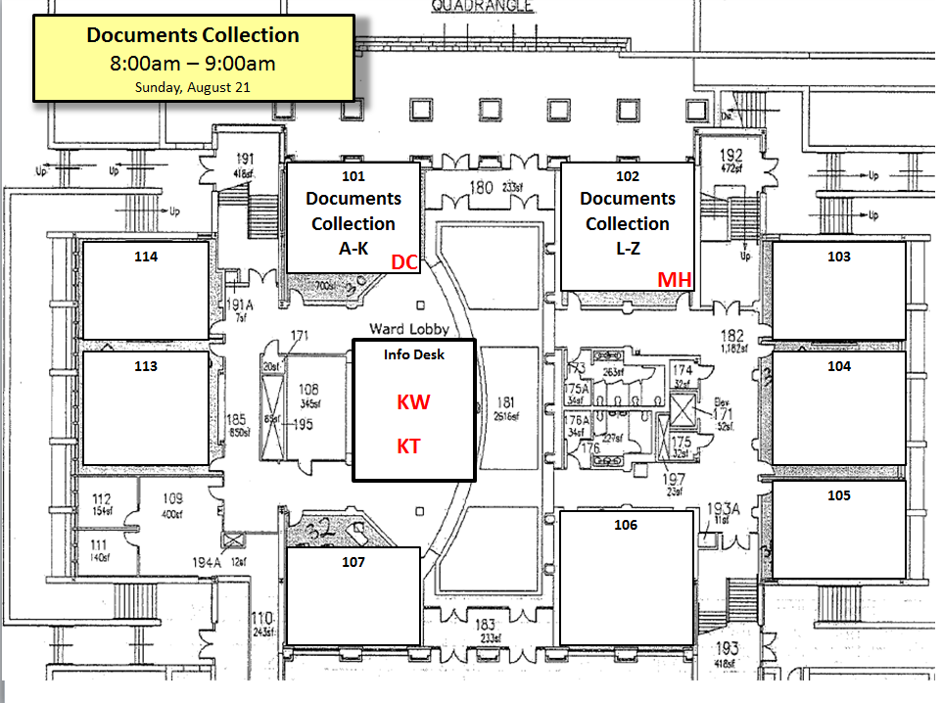
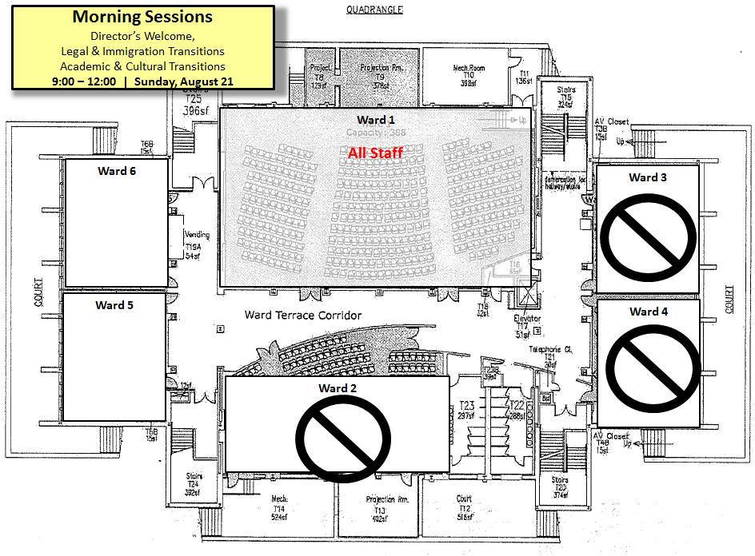
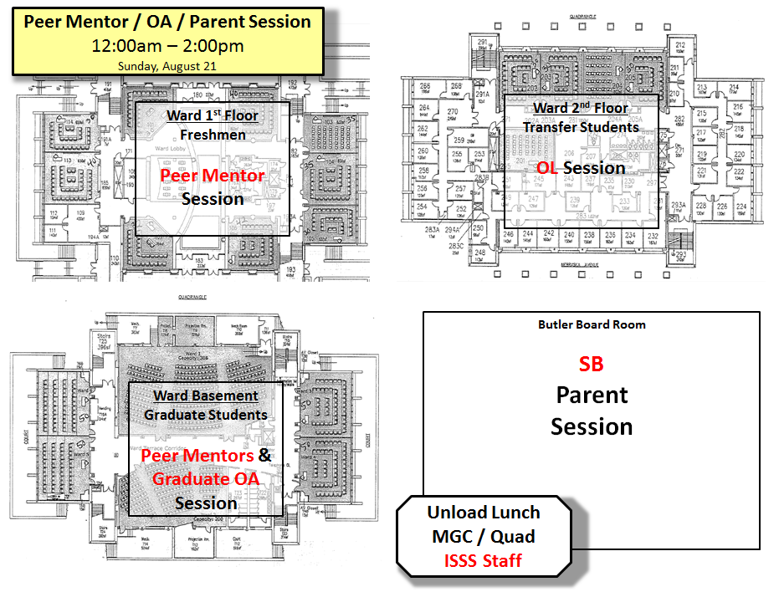

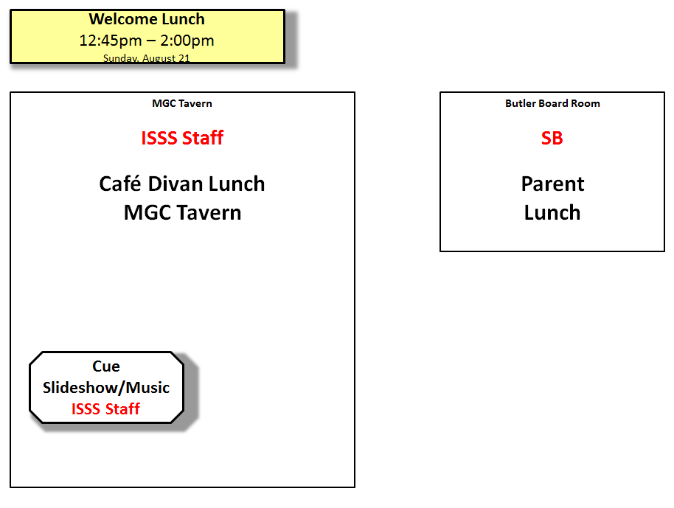
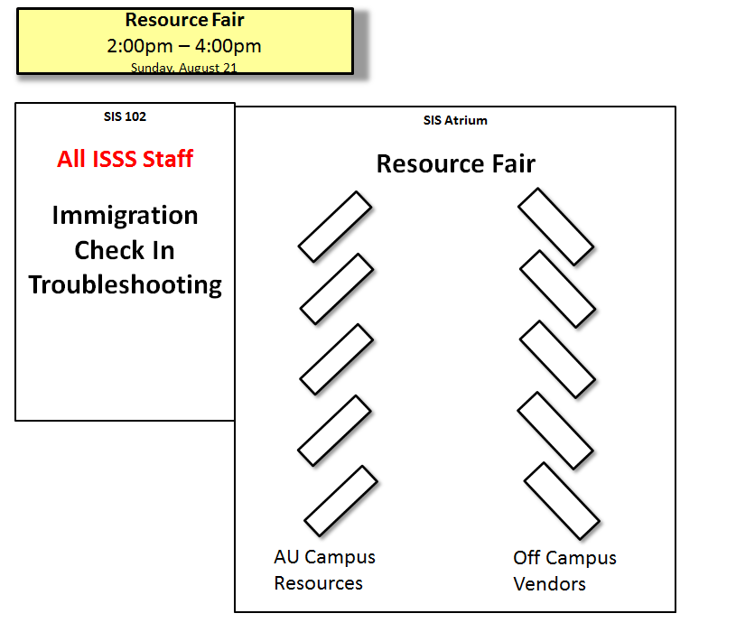
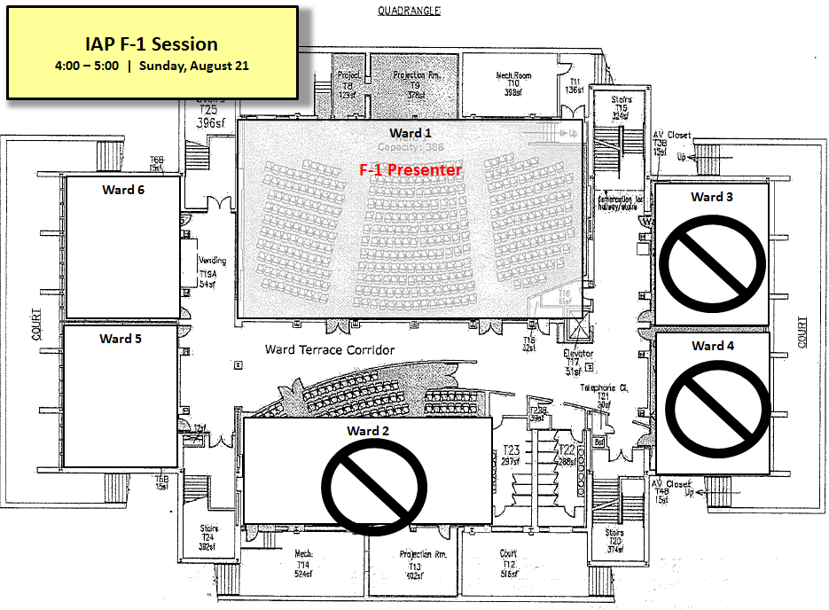
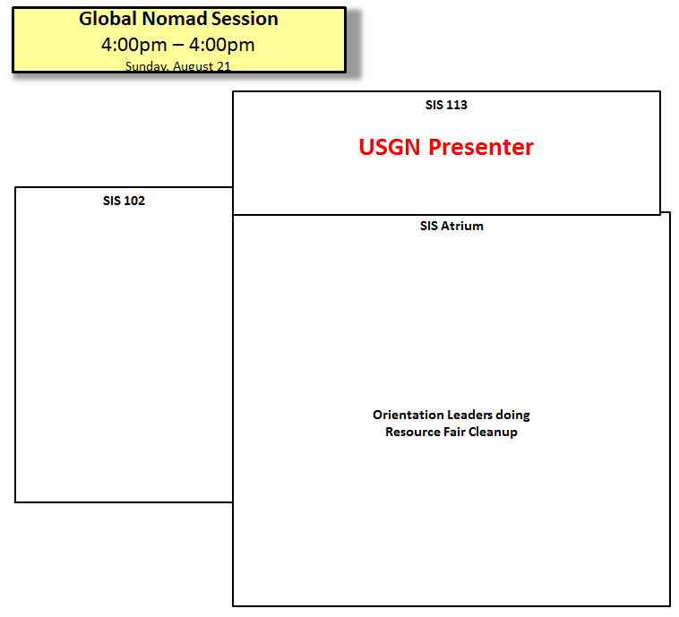
Fall 2016 Learning Outcomes
Legal & Immigration Transitions (DC, JF, KW, Phil Morse)
9:30-11:00 (90 Minutes)
- Off Campus Rights & Responsibilities
- Washington DC Resident Laws
- Empower AU / Sexual Assault Issues
- F-1 & J-1 Status Requirements
- Full-time registration / Immigration Responsibilities
Sociocultural & Academic Transitions (SB, KT, Shams)
11:00-12:00 (60 minutes)
- Culture of Time (synchronic vs. polychromic)
- US Classroom Dynamics (participation; power/distance; collectivist/individual)
- Individual vs. Group Work; Culture of Academic Integrity
- Personal Space / Proxemics
- Gender Roles & Expectations
- Religion, politics, identity/sensitivity
Orientation Mentor Session (Shams, OAs)
12:00-12:45/1:00 (45-60 minutes)
- Ice breaker & name activity
- Learning about New Students
(home country, major, one thing excited about/one thing apprehensive about)
- Student-to-student Q&A
- Campus Tour leading to Lunch
Resource Fair (Shams, SP, OAs)
2:00-4:00 (120 minutes)
- Meet offices and staff that provide student services
(e.g. Career Center, Health Center, Campus Safety, etc)
- Answer questions about deadlines & logistics
(e.g. Health Insurance, Student ID Cards)

Session Learning Outcomes (Fall 2015)

1. Cross Culture Session (Written by KT)
- learning about key concepts of culture. This session raised my awareness about…
  - …style of communication (direct/indirect)
  - …different cultures’ sense of time (monochronic/polychronic)
  - …different cultural values about achievement (“to do” / “to be” cultures)
  - …values around formality (formality / informality)
- thinking about their own cultural values and learning about cultures they may encounter at AU. This session raised my awareness about…
  - …my own cultural preferences
  - … different cultures I may find at American University
- gaining awareness and realistic expectations regarding culture shock. In this session, I was able to…
  - …hear from students about their culture shock
  - …think about situations when I might experience culture shock
- being informed that involvement is an important aspect of adjustment

2. Academics (Written by JP)
- to experience classroom culture in the US, particularly
  - discussion-based Socratic learning
  - small group work
  - model professor/student interactions
  - engage students’ critical thinking, and meta reflection that process
- to learn about the culture of academic integrity
  - Accidental Plagiarism
  - Inappropriate collaboration on take-home projects
  - AIC violations and effects on immigration status
  - AIC adjudication system
- to learn about academic support services at AU. When/how to use…
  - Core Support Network for International Students
  - Writing Lab / Writing Center
  - Academic Support & Access Center
  - University Library
  - Academic Advisor
  - Professors

3. Immigration Session (Written by DC)
- to learn how to maintain immigration status
  - Full-time registration
  - I-20 or DS-2019
  - I-94
  - Passport
  - Immigration check-in
- to learn about immigration documents to travel & re-enter the US
  - Signed I-20/DS-2019
  - Valid F-1/J-1 Visa
  - Proof of enrollment
  - Proof of financial ability
- to learn grounds for termination of status
  - Common Violations
  - Marijuana
  - Student Organizations

4. Campus Resources Fair
Participating Off Campus Vendors
Participating Office | Point Person | Email | Confirmed?
Student Health Center | Edtyhe Anne Cook | edythe@american.edu
Campus Safety | Rima Sifri
CDI | Tiffany Speaks | tspeaks@american.edu
ID Cards/Housing & Dining
Counseling Center | Keum Choi | choi
Student Conduct
Career Center | David Fletcher | fletcher
Off Campus Housing | Christina Medico | medico
Academic Support & Access Center | Shari Pattillo | pattillo
Dean of Students | Jaris Williams | jarisw
Students Activities
Recreational Sports & Fitness
Student Media | Adelle Crowe
Participating Off Campus Vendors
Participating Vendor | Point Person | Email | Confirmed?
Capital One Bank
Bed Bath Beyond | Jim Wilson
ZipCar | Shawn Rutherford
Verizon
Campus Sims
Coutyard Mariott Hotel

Outreach Timeline:
May 15: Identify all of the point people, and email addresses
May 20: Contact all of the participants ask for confirmation. Repeat until
August 15: Deadline for Confirmation of all Participating Offices and Vendors
Outreach Template:

On Campus

Dear

Hello from ISSS! I hope your summer is going well.

We’re in a phase now in which we’re planning for our Fall 2016 Orientation, and we think it would be very beneficial for our student to get to meet you during the program. We’re hosting a Campus Resource Fair on Sunday, August 21th, 2016 starting at 1:30pm in the School of International Service Atrium. Our students will have a couple hours in which to acquaint themselves with the services and staff at your office. Any materials you’d like to share – especially fun swag – are more than welcome. We also think this is a good opportunity for you to meet our students in person so that they’re more apt to use your service in the academic year.

We’d very much like to confirm your participation. If there is someone better from your office to whom I should reach out, I’m happy to do this as well.

Thanks again,

Off Campus

Dear
We are contacting you from the International Student & Scholar Services office at American University in Washington DC. We are planning our Fall 2016 Orientation for International Students.

We think that your company’s services would be very beneficial to our incoming students and would like you to participate in our Campus Partners’ Resource Fair. The fair will take place on Sunday, August 21st, 2016 starting at 1:30pm in the School of International Service Atrium.

Please let us know if you would be willing to participate, if you would like to have further information and if you have any questions.

Thank you very much,
Best,

Example Session Evaluations (Fall 2015)

F visa eval (DC)
How much do you know about the following?

 | A lot | Somewhat | Neutral | Not enough | Not at all
…how many credits per semester are considered full-time study in my program | ○ | ○ | ○ | ○ | ○
…when is it okay to be part-time | ○ | ○ | ○ | ○ | ○
…who can give me permission to be a part-time student | ○ | ○ | ○ | ○ | ○
…how many online classes can I take | ○ | ○ | ○ | ○ | ○
…minimum GPA to be in good academic standing | ○ | ○ | ○ | ○ | ○
…what is I-20 | ○ | ○ | ○ | ○ | ○
…when do I need I-20 | ○ | ○ | ○ | ○ | ○
…who can sign my I-20 before I travel outside the US | ○ | ○ | ○ | ○ | ○
…where is my SEVIS number | ○ | ○ | ○ | ○ | ○
…what is I-94 | ○ | ○ | ○ | ○ | ○
…what is immigration check-in | ○ | ○ | ○ | ○ | ○
…where can I renew my passport | ○ | ○ | ○ | ○ | ○
…where can I renew my visa | ○ | ○ | ○ | ○ | ○
…what documents do I need to re-enter the US | ○ | ○ | ○ | ○ | ○
…what are the common violations and sanctions | ○ | ○ | ○ | ○ | ○
… marijuana regulations and sanctions | ○ | ○ | ○ | ○ | ○
… student organization participation | ○ | ○ | ○ | ○ | ○
…how much time do I have before departing the US after graduation | ○ | ○ | ○ | ○ | ○

I am a …

BA or BS Student
MA or MS Student
PhD Student
Certificate Student
Exchange Student
From (country)
I have studied in the US before | Yes No

F/J visa eval (DC)

How much do you know about the following?

 | A lot | Somewhat | Neutral | Not enough | Not at all
…how many credits per semester are considered full-time study in my program?
…when is it okay to be part-time?
…who can give me permission to be a part-time student?
…how many online classes can I take?
…minimum GPA to be in good academic standing?
…what is I-20/DS-2019?
…when do I need I-20/DS-2019?
…who can sign my I-20 before I travel outside the US?
…where is my SEVIS number?
…what is I-94?
…what is immigration check-in?
…where can I renew my passport?
…where can I renew my visa?
…what documents do I need to re-enter the US?
…how much time do I have before departing the US after graduation?

I am a …

BA or BS Student
MA or MS Student
PhD Student
Certificate Student
Exchange Student
From (country)
I have studied in the US before | Yes No

Academics

How much did you experience the following? | A lot | Somewhat | Neutral | Not enough | Not at all
…group discussion with the whole class?
...realistic professor-to-student interactions?
…challenging questions or issues?
…small group discussions?
…the “feeling” of being in a class?
…concepts that engaged critical thinking?
How much do you now know about the following? | A lot | Somewhat | Neutral | Not enough | Not at all
…how to avoid accidental plagiarism?
…appropriate vs. inappropriate Writing Help?
…correct citations in my writing?
…the culture of Academic Integrity at AU?
…possible effects on my immigration status?
How much do you know about these resources? | A lot | Somewhat | Neutral | Not enough | Not at all
…the Core Support Network (for language help)?
…the Writing Lab?
…the Academic Support & Access Center?
…the AU Library?
…the role of my Academic Advisor?
…the role of my professor?

I am a….
BA or BS Student
MA or MS Student
PhD Student
Certificate Student
From (country)
I have studied in the US before? | YES NO

Cross Culture

This session raised my awareness about… | A lot | Somewhat | Neutral | Not enough | Not at all
…style of communication (direct/indirect)
…sense of social duty (individual / collective)
…different cultures’ sense of time (monochronic/polychronic)
…different cultural values about achievement (“to do” / “to be” cultures)
…values around formality (formality / informality)
…my own cultural preferences
… different cultures I may find at American University

Agree or Disagree

In this session, I was able to…
…hear from students about their culture shock
…think about situations when I might experience culture shock
…get ideas about how I may want to get involved on campus

I am a….
BA or BS Student
MA or MS Student
PhD Student
Certificate Student
I am from (country/ies)
I have studied in the US before: | YES NO

List and Location of Orientation Powerpoints (Fall 2016)

Session Name | How is it used? | Path:  K:\ISSS\Orientation\2016\Fall 2016\Powerpoints\ | Needs update?
Legal & Immigration Transition | Main presentation ppt  9:30-11:00 (Ward 1) | (to be created) | Doesn’t exist yet
Sociocultural & Academic Transition | Main presentation ppt  11:00-12:00 (Ward 1) | (to be created) | Doesn’t exist yet
Parent Session | Main presentation ppt  12:00-2:00 (BBR) | ? | ?
ISSS Intro Slideshow | While students are taking their seats; 8:30am-9:00am (Ward 1) | …\2016--ISSS Office Intro.ppt | Yes  (KW?)
Campus Resource Fair Welcome Desk | On the screen behind Welcome Desk: 2:00-4:00 (SIS Atrium) | …\Campus Resource Fair Welcome Desk.ppt | Yes  (KW?)
Immigration Check In & Troubleshooting | On the overhead in the room Desk: 2:00-4:00 (SIS Atrium) | (pending Sunopsis screens) | Yes  (KW?)
IAP F-1 Immigration Session | Main presentation ppt  4:00-5:00 (Ward 1) |  | Yes  (DC?)
US Global Nomad Breakout Session | Main presentation video  4:00-5:00 (SIS 113) | https://vimeo.com/41264088 | No
Involvement Powerpoint | On the overhead in the doc collection room 8:00-9:00 (Ward 102/101) | …\Involvement Powerpoint.ppt | Yes  (KW?)

List of All Food Orders (Fall 2016)

Event | Type | Vendor | Date | Complete?
Breakfast 8/21 | Mini Bagels | Giant | 08/21/2016
 | Mini Muffins | Giant
 | Fruit | Costco
 | Coffee Service | Aramark
 | Juice | Costco
Mentor Training 1 | Lunch | Satay Club | 04/08/2016
Mentor Training 2 | Lunch | TBD (Likely Pizza) | 08/20/2016
Welcome Lunch | Lunch(add 120 Accelerator Students) | Café Divan | 08/21/2016
Parent Lunch | Lunch | Café Divan | 08/21/2016
Campus Fair Refreshments | Cookies | TBD (Likely Costco) | 08/21/2016
Campus Fair Refreshments | Coffee Service | Aramark | 08/21/2016

List of Supplies Needed (Fall 2016)

Event | Type | Vendor | Date | Complete?
Passport Collection | Envelopes | WB Mason | 08/21/2016
Immig/Legal Session Evals | Yellow Paper | WB Mason | 08/21/2016
Academic & Culture Evals | Blue Paper | WB Mason | 08/21/2016
Overall Eval | Orange Paper | WB Mason | 08/21/2016
OL Training | OL T-Shirts | AU Bookstore  “Christy” | 08/20/2016
Campus Fair Refreshments | Small Plates | WB Mason | 08/21/2016

Examples of Food Orders from Fall 2015
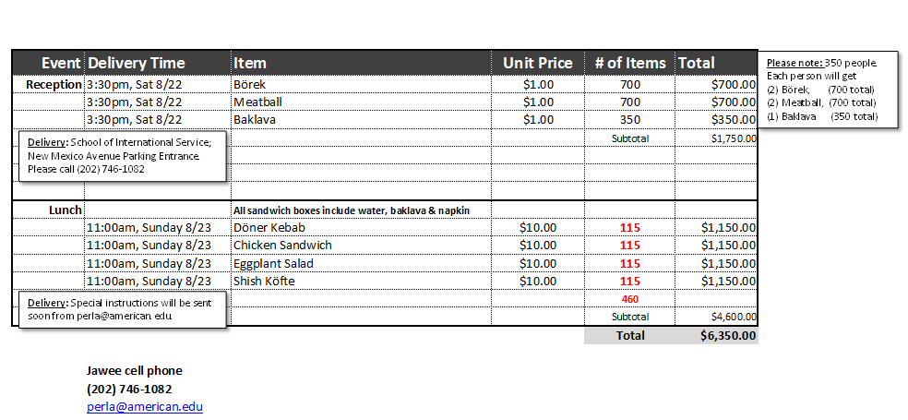

ORIENTATION August 2016 Frequently Asked Questions
On-campus phone numbers: 202-885- +4 digit extension
HOUSING:
On-campus housing: Contact Housing & Dining x3370
Students (with on-campus housing assignments): new student move-in on Saturday, August 20
- Remind students they need to have AU ID first (pick up ID from AU Housing & Dining)

Temporary Housing:
AU does not provide temporary housing. Information about temporary housing, including youth hostels and hotels, for students who plan to live off campus and need a place to stay while searching for housing can be found on the ISSS website: ISSS > Admitted Students > Pre-Arrival checklist > Step 8 Housing > Temporary Housing

Finding off-campus housing:
Info and links on ISSS website: J1 Scholars & Student Interns – Housing & Other Resources http://www.american.edu/ocl/isss/Housing.cfm
Housing Guide & Posting site: office http://www.american.edu/ocl/housing/Off-Campus-Housing-Resources.cfm ; http://www.american.edu/provost/grad/living.cfm
Top non-AU recommendation from students: www.craigslist.org
Housing Facebook group (Open Group within American): student will have to verify their @american.edu address (Type: “Housing” in FB search box; make sure to pick the one related to AU, and ask to join the group)
INTERNATIONAL ORIENTATION DATES:
Optional sessions: Saturday, August 20:
- Optional English Test in SIS 120: 9am – 12:30pm [registration required]
http://www.american.edu/ocl/isss/English-Assessment-Test.cfm

International Orientation Day Sunday, August 21, 2016:
- Orientation Begins with Passport & Immigration Document Check In (8:00am)
- Bring passport and I-20 or DS-2019
Int’l Freshmen: Attend Int’l Orientation Sunday August 21 & then continue with New Student Programs’ Fall Freshmen Fundamentals on Monday, August 22, and Tuesday August 23

Parents: Invited to attend Int’l Orientation Sunday, August 21; Freshmen Fundamentals on Monday, August 22, and Tuesday August 23 (registration & payment required for Monday & Tuesday program)

Int’l Transfers: Attend Int’l Orientation Sunday August 21 & then continue with New Student Programs’ Fall Transfer Transitions on Tuesday, August 23

Int’l Grad students: Attend Int’l Orientation Sunday August 21 & then continue to your department’s orientation (schedules vary – student should contact their dept or see ISSS Grad Student Orientation page)

Abroad@AU – separate orientation program, call Sarah Harlow: x1320 abroadtau@american.edu
Wash. Semester – separate orientation program, call SPExS office: x4900
WCL: Separate programs – call Diana Sawyer 202-274-4368 http://www.wcl.american.edu/orientation/

REGISTERING FOR ORIENTATION:
Freshmen and Transfers: Contact New Student Programs Staff x3303/x3374 or orientation@american.edu – Garrett & his staff next door in OCL. Quick Link: http://american-nso.symplicity.com/students/ OR walk UNDERGRADUATE through the following steps:
- Visit myau.american.edu
- Click Life@AU
- Click New Students. Freshmen: Click on the New First Year Student Checklist. Transfer: Click on New Transfer Student Checklist.
- Click on “Click here to start your checklist”
- Fee ($160 for student), ($85 for each family member $40 for under 12),
(covers meals, program materials, and program activities) - pay on-line at registration

Graduate students – Register on-line through ISSS website (Admitted Students – Pre-arrival checklist – Step 5 Orientation – Graduate Student Orientation) – no fee
http://www.american.edu/ocl/isss/Graduate-Orientation.cfm

REGISTERING FOR CLASSES:
Information was sent to student’s AU e-mail account. Can access link of academic advisors on the registrar website: http://www.american.edu/provost/registrar/courses/advisorylist.cfm
ENGLISH PROFICIENCY TEST (optional but encouraged for non-native speakers of English)
- Saturday, August 20, 9am-12:30pm in SIS
- To register for test: http://www.american.edu/ocl/isss/English-Assessment-Test.cfm
- Silvia Hildesheim will administer the test on August 20

STUDENT ID CARDS:
Contact: Housing & Dining x3370
- ID Card office in Housing & Dining Services in Anderson Hall – open Mon-Thurs: 9-5; Fri: 11:30-5
- Bring a photo ID (passport, driver’s license, etc.)
- Photos can be submitted on-line in advance (myau.american.edu - Life@AU – ID Card Information) or photo taken on-site

MATH PLACEMENT EXAM (UNDERGRADUATES):
Contact: Department of Math and Statistics x3120
Freshmen and transfers should have taken Math Placement Exam online. Most students must take the exam – questions about whether they need to take it can be answered by academic advisors. http://www.american.edu/cas/mathstat/placement/index.cfm
The online test can only be taken once so students who need accommodations will have to arrange for their accommodations before taking it. AU does not grant extra time or attempts to retake the test due to difficulties with the computer or internet connection. Follow this link for a list of minimal system requirements for your computer and internet browser: http://www.americna.edu/cas/mathstat/placement/index.cfm

TUITION BILL:
Contact: AU Central x8000 – aucentral@american.edu, Asbury Building (closed 12-1 and weekends)
Tuition bills are available on student’s myau.american.edu account (Finance-> Eagle Service-> Student Finance) after registering for classes. Tuition payments are due on August 1, 2016.
Payment options at: http://www.american.edu/finance/studentaccounts/Payment-Information.cfm

IMMUNIZATIONS & HEALTH INSURANCE WAIVER:
Contact: Health Center x3380 or Edythe Cook x3201
Health insurance waivers for students who do not want to enroll in AU’s health insurance are due August 1, 2016. Waivers are completed on-line (myau.american.edu, Life@AU). J-1 visa students must also submit separate J-1 insurance form to ISSS.

Any student under the age of 26 attending school in the District of Columbia is required to submit Proof of Immunization against certain diseases. More information and the immunization form are at the Student Health Center website: http://www.american.edu/ocl/healthcenter/Immunization-FAQs.cfm. Please submit original form by mail to Student Health Center: immunizations@american.edu

CONNECT LAPTOP TO WI-FI:
Contact: IT Help Desk x2550 helpdesk@american.edu
Begin date TBD
10:00 a.m.–8:00 p.m., Weekdays, 11:00 a.m.–6:00 p.m., Weekends
Bender Library, First Floor
Stop by to have your laptop configured for AU’s wired and wireless networks, ask tech questions, request assistance, or attend a demonstration. Please bring your laptop and power cord.

ACCESS AU EMAIL ACCOUNT:
Contact: IT Help Desk: Best option is IM Chat: http://www.american.edu/oit/HelpDesk-Chat.cfm
phone: x2550 (may be put on hold) email: helpdesk@american.edu
Myau.american.edu > E-MAIL link (top right corner).

GETTING TO AU FROM THE AIRPORT
http://www.american.edu/ocl/isss/Transportation-Ground.cfm
AU does not provide a pick-up service for students. The student should look on the “Ground Transportation” information provided on the airport website. Typical means of getting from the airport to AU are Metro, bus, SuperShuttle, and taxi.

WHAT ABOUT GLOBAL NOMAD/US CITIZEN STUDENTS FROM OVERSEAS?
“Global nomads” or US citizens coming to AU from overseas are welcome at the ISSS orientation program for freshmen, transfers, and graduate students on August 21. Please encourage them to attend if they wish.

QUESTIONS?
- International Student Orientation questions: intlorientation@american.edu
- Freshmen and transfers with questions about the orientation registration process, or about Thurs/Fri Fall Eagle Summit or Transfer Orientation sessions: Contact New Student Programs x3303 or x3374 email: orientation@american.edu – or visit Garrett and his staff in OCL suite

ISSS FRONT DESK PROCEDURES
CLEARANCE (PHOTOCOPYING STUDENT IMMIGRATION DOCUMENTS):
Before August 19: WAIT to do clearance photocopies and check-in until orientation on Weds. Morning. Instruct students to bring documents to orientation.
From August 19 on:
Make clearance photocopies for new students and have them complete online check-in.
- Student fills out yellow clearance form
- ISSS staff: photocopy docs
- Update ISSIS advising history: “CLR Received”
- Paperclip pink “Clearance Done” slip of paper in passport
- Put packet in “Clearance documents” box at front desk for Mira to process
- Help student do on-line check-in in ISSS

IMMIGRATION MAKE UP SESSIONS:
Please do not advertise to students unless they absolutely cannot attend orientation!
Anyone arriving after August 21: Check which orientation they were to attend (Washington Semester, WCL, Abroad@AU, all have separate orientation programs). If they missed their orientation program, they should come in to ISSS, have their documents photocopied for clearance, and sign up for a make-up session. If it is very busy in the office you can wait to have them do on-line check-in at the session, which will be in Anderson Computer Lab.

Make Up Session Dates (choose one):
Tuesday, August 30, 10:00-12:00 (MGC 245)
Thursday, September 1, 2:00-4:00 (MGC 245)
Monday, September 5, 2:00-4:00 (MGC 245)
Wednesday, September 7, 10:00-12:00 (MGC 245)

Website
The Orientation Pages on the website are the following (1) Orientation Landing page, which directs incoming international students to the relevant sub-page for their orientation (2) Freshmen F/J page (2) Global Nomad Page (3) Parent Page (4) Transfer Student Page (5) Graduate Student Orientation Page (6) Abroad at AU Page (7) Washington Semester (8) Washington College of Law. (9) International Accelerator Program. The last two, WCL and IAP are not maintained by ISSS.
Web Page | URL
Orientation Landing | http://www.american.edu/ocl/isss/orientation.cfm
Freshmen | http://www.american.edu/ocl/isss/intl-orientation-freshmen.cfm
Global Nomad | http://www.american.edu/ocl/isss/orientation-global-nomad.cfm
Parent | http://www.american.edu/ocl/isss/International-Parent-Orientation-Page.cfm
Transfer Student | http://www.american.edu/ocl/isss/intl-orientation-transfer.cfm
Graduate Student | http://www.american.edu/ocl/isss/Graduate-Orientation.cfm
Abroad at AU | http://www.american.edu/ocl/isss/Abroad-at-AU-January-Orientation.cfm
Washington Semester | http://www.american.edu/ocl/isss/WSEM-orientation.cfm
Washington College of Law | https://www.wcl.american.edu/orientation/
International Accelerator | http://www.auaccelerator.com/before-you-arrive

Budget
Overview
Date Needed | Orientation Event | Item | Caterer/Source | Number of People | Total Cost
8-Apr | OL Training Orientation | Dinner | Satay Club | 40 | $430.00
21-Aug | OL T-shirts | T-Shirt | Campus store | 35 | $122.00
21-Aug | Supplies | Laces, Sticker Dots | WB Mason | 500
21-Aug | Orientation Breakfast | Coffee & Tea | Avenues Catering | 500 | $1,130.00
21-Aug | Orientation Refreshments Resource Fair | Lemonade, Ice Water | Avenues Catering | 500 | $478.38
20-Aug | OL Training lunch | Pizza | Pizza | 30 | $180.71
21-Aug | Orientation Lunch | Sandwiches | Café Divan | 540
22-Aug | OL Thank you lunch | Food | Satay Club | 20 | $276.00

Global Cafe
Overview
Global Café is held every Friday of the first month the Fall and Spring semesters. New and returning students are invited to socialize together, listen to international music and have some snacks.
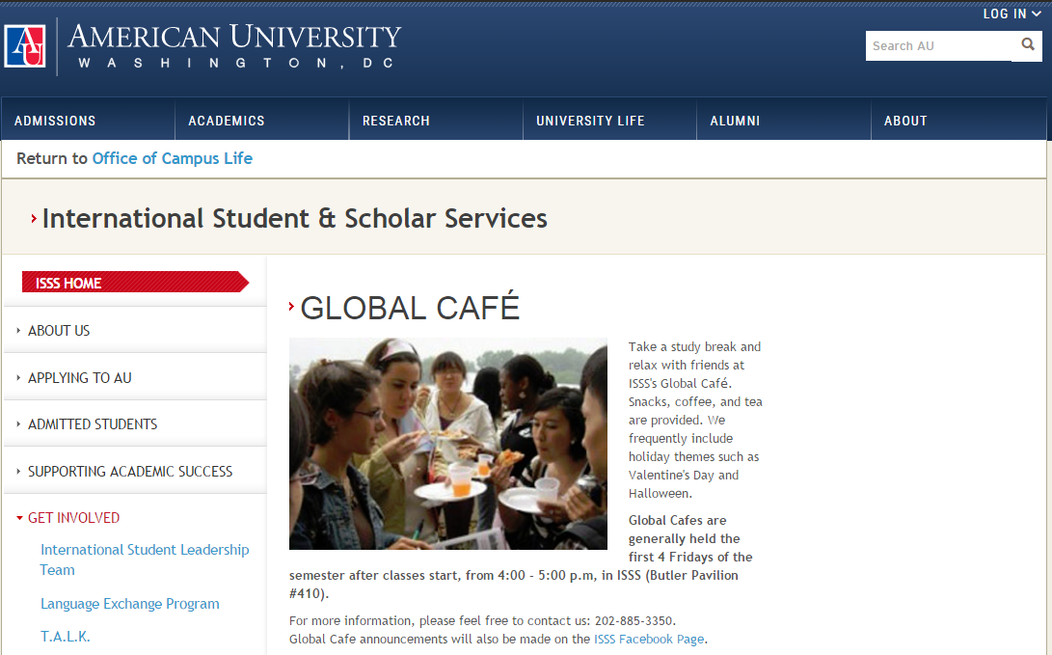
http://www.american.edu/ocl/isss/globalcafe.cfm
Fall 2016 Global Café Dates
- Friday, September 2
- Friday, September 9
- Friday, September 16
- Friday, September 23
- Friday, September 30
Catering: Costco
Snacks are purchased before the first Global Café and replenished on an as-needed basis. Generally, the first Global Café will have (1) Fruits such as grapes or oranges that don’t require slicing or prep (2) cookies (3) chips (4) dips, (e.g. salsa)

